**OHAN REDDY NAGAR, ELAMANDYAM (V), RENIGUNTA (M), TIRUPATI- 517520, A.P.**

**(Approved by AICTE, New Delhi & affiliated to JNTUA, ANANTAPURAMU)**

**AN ISO 9001-2008 CERTIFIED INSTITUTE**

**YOGANANDA INSTITUTE OF TECHNOLOGY AND SCIENCE**

**Department of Computer Science and Engineering**

**Assistant professor**

Mrs .Y. REDDEMMA , M.Tech

UNDER THE ESTEEMED GUIDENCE OF

**184P1A0557**

**-**

**O.ARAVIND**

By

COMPUTER SCIENCE ENGINEERING

**In**

BACHELOR OF TECHNOLOGY

In partial fulfillments of the requirements for the award of the degree

**ANANTAPURAMU**

**JAWAHARLAL NEHRU TECHNOLOGICAL UNIVERSITY ANANTAPUR,**

Submitted to

**“SIXTH SENSE TECHNOLOGY”**

A TECHNICAL SEMINAR REPORT ON



**Submitted on :**

**INTERNAL EXAMINER EXTERNAL EXAMINER**

**Department of CSE.**

**Department of CSE.**

**Department of CSE.**

**Assistant Professor,**

**Assistant Professor,**

**Assosiate Professor,**

**Mrs. Y. REDDEMMA Dr. N .MURALI**

**Guided by**

**Seminar Co-Ordinator**

**Head of the department**

This is to certify that the seminar report entitled “SIXTH SENSE TECHNOLOGY” is the bonafide work of **O.ARAVIND** on bearing Roll no.**184P1A0557** who carried and the Seminar work under my supervision . Certified further, that to the best of my knowledge the work reported here in does not form part of any other seminar report on the basis of which a degree in Bachelor of Technology is awarded conferred on an earlier occasion on this or any other candidate.

**CERTIFICATE**

**DEPARTMENT OF COMPUTER SCIENCE AND ENGINEERING**

**MOHAN REDDY NAGAR, ELAMANDYAM (V), RENIGUNTA (M),TIRUPATI -517520, A.P.**

**(Approved by AICTE, New Delhi & affiliated to JNTUA, ANANTAPURAM)**

**AN ISO 9001-2008 CERTIFIED INSTITUTE**

**YOGANANDA INSTITUTE OF TECHNOLOGY AND SCIENCE**



support given to me during the work.

**(184P1A0557 )**

**O.ARAVIND**

Last but not least I thank our Lab Assistants, Parents and Friends for the valuable

For guiding me and having provided with all the facilities and support in completing my

Seminar successfully.

**I** express my sincere thanks to our Seminar Guide **Mrs .Y. REDDEMMA, M.TECH**

**I** thankful to **Dr.N. MURALI** , **Ph.D,** Head of the Department of Computer

Science and Engineering for the valuable support given to me.

the support in completing my Seminar successfully.

**M**y sincere thanks to our Principal for giving **Dr . GEETHA RAJ , Ph.D** me

provided all the facilities and support in completing my Seminar successfully.

**I** express my sincere thanks to our Chairman **Sri D. MOHAN REDDY** for having

encouragement crown all efforts with Success.

incomplete without mention of the people who made it possible who constant guidance and

This satisfaction that accompanies the successful completion of task would be

**ACKNOWLEDEMENT**

nnnn

**( 184P1A0557 )**

**O.ARAVIND**

**( 184P1A0557 )**

**O.ARAVIND**

s

**DECLARATION**

**I** hereby declar that the Seminar work entitled **“SIXTH SENSE TECHNOLOGY”**

Under esteemed guidance of  **Mrs. Y. REDDEMMA , M.TECH** is submitted in partial fulfillment of the requirement for the award of the degree of **Bachelor of Technology** in

**Computer Science & Engineering** at **Yogananda Institute of Technology & Science, Tirupati** affiliated to **Jawaharlal Nehru Technological University Anantapur**, **Anantapuramu** during the academic year **2021-2022**.This work has not been submitted by anybody for towards the award of any degree.

Student Signature

**O.ARAVIND**

**184P1A0557**

##### TABLE OF CONTENTS

**CHAPTER NO TITLE PAGE NO.**

##### ABSTRACT

1. INTRODUCTION 1
2. SIXTH SENSE TECHNOLOGY 2
   1. WHAT IS SIXTH SENSE 3
   2. EARLIER SIXTH SENSE PROTOTYPE 3
   3. RECENT PROTOYPE 4
3. WORKING OF SIXTH SENSE
   1. COMPONENTS 6
      1. CAMERA 7
      2. PROJECTOR 7
      3. MIRROR 8
      4. MOBILE COMPONENT 8
      5. COLOR MARKERS 9
   2. WORKING 9
4. RELATED TECHNOLOGY 12
   1. AUGMENTED REALITY 12
   2. GESTURE RECOGNITION 13
   3. COMPUTER VISION BASED ALGORITHM 15
   4. TECHNOLOGIES THAT USES SIXTH SENSEAS PLATFORM 17

|  |  |  |
| --- | --- | --- |
| **5. APPLICATIONS** |  | **18** |
| **5.1** | **MAKE A CALL** | **19** |
| **5.2** | **CALL UP A MAP** | **20** |
| **5.3** | **CHECK THE TIME** | **21** |
| **5.4** | **CREATE MULTIMEDIA**  **READING EXPERIENCE** | **22** |

1. **ADVANTAGES AND ENHANCEMENTS 26**

##### ADVANTAGES 27

* 1. **FUTURE ENHANCEMENTS 28**

ABSTRACT

Sixth Sense Technology integrates digital information into the physical world and its objects, making the entire world your computer. It can turn any surface into a touch-screen for computing, controlled by simple hand gestures. It is not a technology which is aimed at changing human habits but causing computers and other machines to adapt to human needs. It also supports multi user and multi touch provisions. Sixth Sense device is a mini-projector coupled with a camera and a cell phone-which acts as the computer and your connection to the Cloud, all the information stored on the web. The current prototype costs around $350. The Sixth Sense prototype is used to implement several applications that have shown the usefulness, viability and flexibility of the system. The Sixth Sense recognizes the objects around us and displays the information relating to those objects in a real time environment. The Sixth Sensetechnology allows the user to interact the information through hand gestures. This is a quiet efficient way compared to the text and graphic based user interface. It has the potential to form the transparent user interface for accessing the information around us

**INTRODUCTION**

We’ve evolved over millions of years to sense the world around us. When we encounter something, someone or some place, we use our five natural senses which includes eye, ear, nose, tongue mind and body to perceive information about it; that information helps us make decisions and chose the right actions to take. But arguably the most useful information that can help us make the right decision is not naturally perceivable with our five senses, namely the data, information and knowledge that mankind has accumulated about everything and which is increasingly all available online.

Although the miniaturization of computing devices allows us to carry computers in our pockets, keeping us continually connected to the digital world, there is no link between our digital devices and our interactions with the physical world. Information is confined traditionally on paper or digitally on a screen. SixthSense bridges this gap, bringing intangible, digital information out into the tangible world, and allowing us to interact with this information via natural hand gestures. ‘SixthSense’ frees information from its confines by seamlessly integrating it with reality, and thus making the entire world your computer.

“

tially produced a wristband that would read an Radio Frequency Identification tag to know, for examplSixth Sense Technology”, it is the newest jargon that has proclaimed its presence in the technical arena. This technology has emerged, which has its relation to the power of these six senses. Our ordinary computers will soon be able to sense the different feelings accumulated in the surroundings and it is all a gift of the ”Sixth Sense Technology” newly introduced.

**SixthSense** is a wearable “gesture based” device that augments the physical world with digital information and lets people use natural hand gestures to interact with that information. It was developed by Pranav Mistry, a PhD student in the Fluid Interfaces Group at the MIT Media Lab. A grad student with the Fluid Interfaces Group at MIT, he caused a storm with his creation of SixthSense. He says that the movies “Robocop” and “Minority Report” gave him the inspiration to create his view of a world not dominated by computers, digital information and human robots, but one where computers and other digital devices enhance people’s enjoyment of the physical world.

Right now, we use our “devices” *(computers, mobile phones, tablets, etc.)* to go into the internet and get information that we want. With SixthSense we will use a device no bigger

than current cell phones and probably eventually as small as a button on our shirts to bring the internet to us in order to interact with our world!

SixthSense will allow us to interact with our world like never before. We can get information on anything we want from anywhere within a few moments! We will not only be able to interact with things on a whole new level but also with people! One great part of the device is its ability to scan objects or even people and project out information regarding what you are looking at.

**Chapter 2**

## SIXTH SENSE TECHNOLOGY

### What is SixthSense?

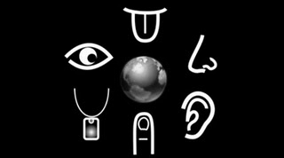

Figure 2.1: Six Senses

Sixth Sense in scientific (or non-scientific) terms is defined as Extra Sensory Perception or in short ESP. It involves the reception of information not gained through any of the five senses. Nor is it taken from any experiences from the past or known. Sixth Sense aims to more seamlessly integrate online information and tech into everyday life. By making available information needed for decision-making beyond what we have access to with our five senses, it effectively gives users a sixth sense.

### Earlier SixthSense Prototype

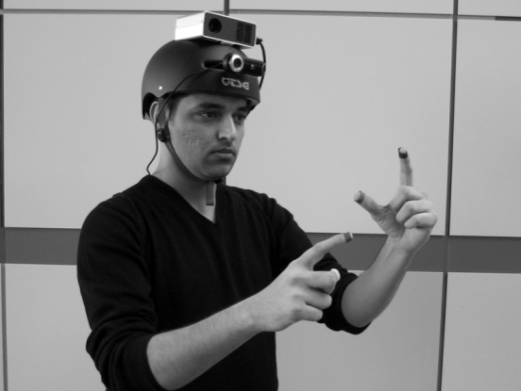

Figure 2.2: Earlier Device

Maes’ MIT group, which includes seven graduate students, were thinking about how a person could be more integrated into the world around them and access information

having to do something like take out a phone. They inie, which book a user is holding in a store.

They also had a ring that used infrared to communicate by beacon to supermarket smart shelves to give you information about products. As we grab a package of macaroni, the ring would glow red or green to tell us if the product was organic or free of peanut traces — whatever criteria we program into the system.

They wanted to make information more useful to people in real time with minimal effort in a way that doesn’t require any behaviour changes. The wristband was getting close, but we still had to take out our cell phone to look at the information.

That’s when they struck on the idea of accessing information from the internet and projecting it. So someone wearing the wristband could pick up a paperback in the bookstore and immediately call up reviews about the book, projecting them onto a surface in the store or doing a keyword search through the book by accessing digitized pages on Amazon or Google books.

They started with a larger projector that was mounted on a helmet. But that proved cumbersome if someone was projecting data onto a wall then turned to speak to friend — the data would project on the friend’s face.

### Recent Prototype

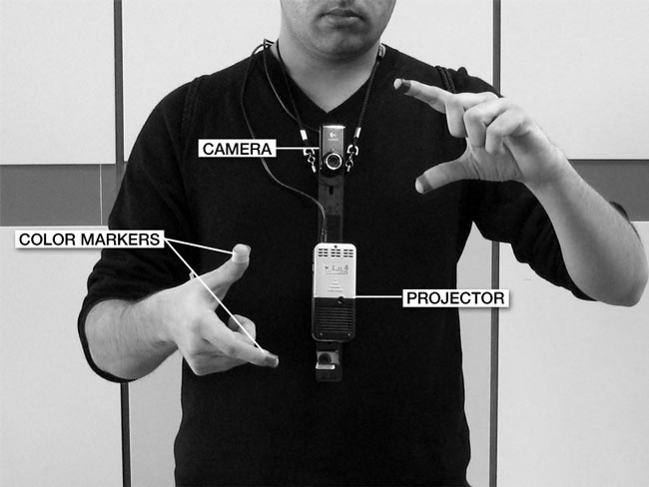

Figure 2.3:present device

Now they have switched to a smaller projector and created the pendant prototype to be worn around the neck.

The SixthSense prototype is composed of a pocket projector, a mirror and a camera. The hardware components are coupled in a pendant-like mobile wearable device. Both the projector and the camera are connected to the mobile computing device in the user’s pocket.

We can very well consider the Sixth Sense Technology as a blend of the computer and the cell phone. It works as the device associated to it is hanged around the neck of a person and thus the projection starts by means of the micro projector attached to the device. Therefore, in course, you turn out to be a moving computer in yourself and the fingers act like a mouse and a keyboard.

The prototype was built from an ordinary webcam and a battery-powered 3M projector, with an attached mirror — all connected to an internet-enabled mobile phone. The setup, which costs less than $350, allows the user to project information from the phone onto any surface — walls, the body of another person or even your hand.

Mistry wore the device on a lanyard around his neck, and colored Magic Marker caps on four fingers (red, blue, green and yellow) helped the camera distinguish the four fingers and recognize his hand gestures with software that Mistry created.

**chapter 3**

## WORKING OF SIXTH SENSE TECHNOLOGY

### Components

The hardware components are coupled in a pendant like mobile wearable device**.**

* + - Camera
    - Projector
    - Mirror
    - Mobile Component
    - Color Markers

### Camera

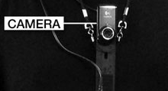

Figure 3.1: Camera

A webcam captures and recognises an object in view and tracks the user’s hand gestures using computer-vision based techniques.

It sends the data to the smart phone. The camera, in a sense, acts as a digital eye, seeing what the user sees. It also tracks the movements of the thumbs and index fingers of both of the user's hands. The camera recognizes objects around you instantly, with the micro- projector overlaying the information on any surface, including the object itself or your hand.

### Projector

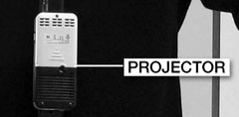

Figure 3.2: Projector

Also, a projector opens up interaction and sharing. The project itself contains a battery inside, with 3 hours of battery life. The projector projects visual information enabling surfaces, walls and physical objects around us to be *used as interfaces*. We want this thing to merge with the physical world in a real physical sense. You are touching that object and projecting info onto that object. The information will look like it is part of the object*.* A tiny LED projector displays data sent from the smart phone on any surface in view–object, wall, or person.

### Mirror

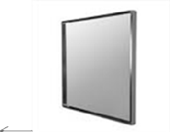

Figure 3.3: Mirror

The usage of the mirror is significant as the projector dangles pointing downwards from the neck.

### Mobile Component

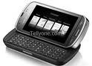

Figure 3.4: Smartphone

The mobile devices like Smartphone in our pockets transmit and receive voice and data anywhere and to anyone via the mobile internet. An accompanying Smartphone runs the SixthSense software, and handles the connection to the internet. A Web-enabled smart phone in the user’s pocket processes the video data. Other software searches the Web and interprets the hand gestures.

### Color Markers

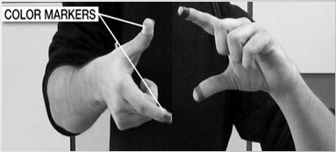

Figure 3.5: Color Markers

It is at the tip of the user’s fingers. Marking the user’s fingers with red, yellow, green, and blue tape helps the webcam recognize gestures. The movements and arrangements of these makers are interpreted into gestures that act as interaction instructions for the projected application interfaces.

### Working

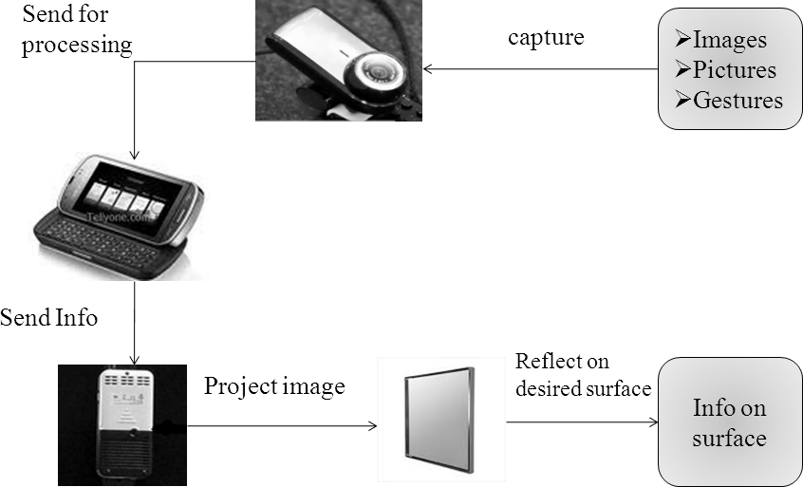

Figure 3.6: Working

* + - The hardware that makes Sixth Sense work is a pendant like mobile wearable interface
    - It has a camera, a mirror and a projector and is connected wirelessly to a Bluetooth or 3G or wifi smart phone that can slip comfortably into one’s pocket
    - The camera recognizes individuals, images, pictures, gestures one makes with their hands
    - Information is sent to the Smartphone for processing
    - The downward-facing projector projects the output image on to the mirror
    - Mirror reflects image on to the desired surface
    - Thus, digital information is freed from its confines and placed in the physical world

The entire hardware apparatus is encompassed in a pendant-shaped mobile wearable device. Basically the camera recognises individuals, images, pictures, gestures one makes with their hands and the projector assists in projecting any information on whatever type of surface is present in front of the person. The usage of the mirror is significant as the projector dangles pointing downwards from the neck. To bring out variations on a much higher plane, in the demo video which was broadcasted to showcase the prototype to the world, Mistry uses coloured caps on his fingers so that it becomes simpler for the software to differentiate between the fingers, demanding various applications.

The software program analyses the video data caught by the camera and also tracks down the locations of the coloured markers by utilising single computer vision techniques. One can have any number of hand gestures and movements as long as they are all reasonably identified and differentiated for the system to interpret it, preferably through unique and varied fiducials. This is possible only because the ‘Sixth Sense’ device supports multi-touch and multi-user interaction.

MIT basically plans to augment reality with a pendant picoprojector: hold up an object at the store and the device blasts relevant information onto it (like environmental stats, for instance), which can be browsed and manipulated with hand gestures. The "sixth sense" in question is the internet, which naturally supplies the data, and that can be just about anything

-- MIT has shown off the device projecting information about a person you meet at a party on that actual person (pictured), projecting flight status on a boarding pass, along with an entire non-contextual interface for reading email or making calls. It's pretty interesting technology that, like many MIT Media Lab projects, makes the wearer look like a complete dork -- if the projector doesn't give it away, the colored finger bands the device uses to detect finger motion certainly might.

The idea is that SixthSense tries to determine not only what someone is interacting with, but also how he or she is interacting with it. The software searches the internet for information that is potentially relevant to that situation, and then the projector takes over.

All the work is in the software," says Dr Maes. "The system is constantly trying to figure out what's around you, and what you're trying to do. It has to recognize the images you see, track your gestures, and then relate it all to relevant information at the same time."

The software recognizes 3 kinds of gestures:

* + - Multitouch gestures, like the ones you see in Microsoft Surface or the iPhone -- where you touch the screen and make the map move by pinching and dragging.
    - Freehand gestures, like when you take a picture [as in the photo above]. Or, you might have noticed in the demo, because of my culture, I do a namaste gesture to start the projection on the wall.
    - Iconic gestures, drawing an icon in the air. Like, whenever I draw a star, show me the weather. When I draw a magnifying glass, show me the map. You might want to use other gestures that you use in everyday life. This system is very customizable.

The technology is mainly based on hand gesture recognition, image capturing, processing, and manipulation, etc. The map application lets the user navigate a map displayed on a nearby surface using hand gestures, similar to gestures supported by multi-touch based systems, letting the user zoom in, zoom out or pan using intuitive hand movements. The drawing application lets the user draw on any surface by tracking the fingertip movements of the user’s index finger.

.

**Chapter 4**

## RELATED TECHNOLOGIES

SixthSense’ technology takes a different approach to computing and tries to make the digital aspect of our lives more intuitive, interactive and, above all, more natural. We shouldn’t have to think about it separately. It’s a lot of complex technology squeezed into a simple portable device. When we bring in connectivity, we can get instant, relevant visual information projected on any object we pick up or interact with The technology is mainly based on hand augmented reality, gesture recognition, computer vision based algorithm etc.

### Augmented reality

**Augmented reality** (AR) is a term for a live direct or indirect view of a physical real- world environment whose elements are *augmented* by virtual computer-generated imagery. It is related to a more general concept called mediated reality in which a view of reality is modified (possibly even diminished rather than augmented) by a computer. The augmentation is conventionally in real-time and in semantic context with environmental elements.

Sixth sense technology which uses Augmented Reality concept to super imposes digital information on the physical world. With the help of advanced AR technology (e.g. adding computer vision and object recognition) the information about the surrounding real world of the user becomes interactive and digitally usable. Artificial information about the environment and the objects in it can be stored and retrieved as an information layer on top of the real world view.

The main hardware components for augmented reality are: display, tracking, input devices, and computer. Combination of powerful CPU, camera, accelerometers, GPS and solid state compass are often present in modern Smartphone, which make them prospective platforms. There are three major display techniques for Augmented Reality:

* Head Mounted Displays
* Handheld Displays
* Spatial Displays

##### Head Mounted Displays

A Head Mounted Display (HMD) places images of both the physical world and registered virtual graphical objects over the user's view of the world. The HMD's are either optical see- through or video see-through in nature.

##### Handheld Displays

Handheld Augment Reality employs a small computing device with a display that fits in a user's hand. All handheld AR solutions to date have employed video see-through techniques to overlay the graphical information to the physical world. Initially handheld AR employed sensors such as digital compasses and GPS units for its six degree of freedom tracking sensors.

##### Spatial Displays

Instead of the user wearing or carrying the display such as with head mounted displays or handheld devices; Spatial Augmented Reality (SAR) makes use of digital projectors to display graphical information onto physical objects.

Modern mobile augmented reality systems use one or more of the following tracking technologies: digital cameras and/or other optical sensors, RFID, wireless sensors etc. Each of these technologies have different levels of accuracy and precision. Most important is the tracking of the pose and position of the user's head for the augmentation of the user's view.

For users with disabilities of varying kinds, AR has real potential to help people with a variety of disabilities. Only some of the current and future AR applications make use of a Smartphone as a mobile computing platform.

### Gesture Recognition

**Gesture recognition** is a topic in computer science and language technology with the goal of interpreting human gestures via mathematical algorithms. Gestures can originate from any bodily motion or state but commonly originate from the face and hand. Current focuses in the field include emotion recognition from the face and hand gesture recognition. Many approaches have been made using cameras and computer vision algorithms to interpret sign language.

Gestures can exist in isolation or involve external objects. Free of any object, we wave, beckon, fend off, and to a greater or lesser degree (depending on training) make use of more formal sign languages. With respect to objects, we have a broad range of gestures that are almost universal, including pointing at objects, touching or moving objects, changing object shape, activating objects such as controls, or handing objects to others.

Gesture recognition can be seen as a way for computers to begin to understand human body language, thus building a richer bridge between machines and humans than primitive text user interfaces or even GUIs (graphical user interfaces), which still limit the majority of input to keyboard and mouse. Gesture recognition enables humans to interface with the machine (HMI) and interact naturally without any mechanical devices.

Gestures can be used to communicate with a computer so we will be mostly concerned with empty handed semiotic gestures. These can further be categorized according to their functionality.

##### Symbolic gestures

These are gestures that, within each culture, have come to a single meaning. An Emblem such as the “OK” gesture is one such example, however American Sign Language gestures also fall into this category.

##### Deictic gestures

These are the types of gestures most generally seen in HCI and are the gestures of pointing, or otherwise directing the listeners attention to specific event or objects in the environment.

##### Iconic gestures

As the name suggests, these gestures are used to convey information about the size, shape or orientation of the object of discourse. They are the gestures made when someone says “The plane flew like this”, while moving their hand through the air like the flight path of the aircraft.

##### Pantomimic gestures:

These are the gestures typically used in showing the use of movement of some invisible tool or object in the speaker’s hand. When a speaker says “I turned the steering wheel hard to the left”, while mimicking the action of turning a wheel with both hands, they are making a pantomimic gesture.

Using the concept of gesture recognition, it is possible to point a finger at the computer screen so that the cursor will move accordingly. This could potentially make conventional input devices such as mouse, keyboards and even touch-screens redundant. Gesture recognition can be conducted with techniques from computer vision and image processing. The literature includes ongoing work in the computer vision field on capturing gestures or more general human pose and movements by cameras connected to a computer.

### Computer vision based algorithm

Computer vision is the science and technology of machines that see. As a scientific discipline, computer vision is concerned with the theory behind artificial systems that extract information from images. The image data can take many forms, such as video sequences, views from multiple cameras, or multi-dimensional data from a medical scanner.

Computer vision, on the other hand, studies and describes the processes implemented in software and hardware behind artificial vision systems. The software tracks the user’s gestures using computer-vision based algorithms. Computer vision is, in some ways, the inverse of computer graphics. While computer graphics produces image data from 3D models, computer vision often produces 3D models from image data. There is also a trend towards a combination of the two disciplines, e.g., as explored in augmented reality.

The fields most closely related to computer vision are image processing, image analysis and machine vision. Image processing and image analysis tend to focus on 2D images, how to transform one image to another. his characterization implies that image processing/analysis neither require assumptions nor produce interpretations projected onto one or several images, e.g., how to reconstruct structure or other information about the 3D scene from one or several images. Machine vision tends to focus on applications, mainly in manufacturing, e.g., vision based autonomous robots and systems for vision based inspection or measurement.

##### The Recognition Algorithms

The computer vision system for tracking and recognizing the hand postures that control the menus is based on a combination of multi-scale color feature detection, view based hierarchical hand models and particle filtering. The hand postures or states are represented in terms of hierarchies of multi-scale color image features at different scales, with qualitative inter-relations in terms of scale, position and orientation. In each image, detection of multiscale color features is performed. The hand postures are then simultaneously detected and tracked using particle filtering, with an extension of layered sampling referred to as hierarchical layered sampling. To improve the performance of the system, a prior on skin color is included in the particle filtering.

* 1. **Technologies that uses Sixth Sense as Platform**

SixthSense technology takes a different approach to computing and tries to make the digital aspect of our lives more intuitive, interactive and, above all, more natural. When you bring in connectivity, you can get instant, relevant visual information projected on any object you pick up or interact with. So, pick up a box of cereal and your device will project whether it suits your preferences. Some of the technologies that uses this are Radio Frequency Identification, gesture gaming, washing machine.

##### Radio Frequency Identification

SixthSense is a platform for Radio Frequency Identification based enterprise intelligence that combines Radio Frequency Identification events with information from other enterprise systems and sensors to automatically make inferences about people, objects, workspaces, and their interactions.

Radio Frequency Identification is basically an electronic tagging technology that allows the detection and tracking of tags and consequently the objects that they are affixed to. This ability to do remote detection and tracking coupled with the low cost of passive tags has led to the widespread adoption of RFID in supply chains worldwide.

Pranav Mistry, a researcher at the media lab of the Massachusetts Institute Technology, has developed a 'sixth sense' device – a gadget worn on the wrist that can function as a 'touch screen' device for many modern applications. The gadget is capable of selecting a product either by image recognition or radio frequency

The idea of SixthSense is to use Radio Frequency Identification technology in conjunction with a bunch of other enterprise systems such as the calendar system or online presence that can track user activity. Here, we consider an enterprise setting of the future where people (or rather their employee badges) and their personal objects such as books, laptops, and mobile phones are tagged with cheap, passive RFID tags, and there is good coverage of RFID readers in the workplace.

SixthSense incorporates algorithms that start with a mass of undifferentiated tags and automatically infer a range of information based on an accumulation of observations. The technology is able to automatically differentiate between people tags and object tags, learn the identities of people, infer the ownership of objects by people, learn the nature of different zones in a workspace (e.g., private office versus conference room), and perform other such inferences.

By combining information from these diverse sources, SixthSense records all tag-level events in a raw database. The inference algorithms consume these raw events to infer events at the level of people, objects, and workspace zones, which are then recorded in a separate processed database. Applications can either poll these databases by running SQL queries or set up triggers to be notified of specific events of interest.

SixthSense infers when a user has interacted with an object, for example, when you pick up your mobile phone. It is a platform in that its programming model makes the inferences made automatically available to applications via a rich set of APIs. To demonstrate the capabilities of the platform, the researchers have prototyped a few applications using these APIs, including a misplaced object alert service, an enhanced calendar service, and rich annotation of video with physical events.

##### Sixth Sense Washing Machine

Whirlpool AWOE 8758 White Washing Machine is a remarkable front loader that incorporates the unparalleled Sixth Sense technology. Whirlpool’s 2009 range of washing machines comes integrated with enhanced 6th sense technology that gives more optimisation of resources and also increased saving in terms of energy, water

more optimisation of resources and also increased saving in terms of energy, water and time.

Ideal washing machine for thorough washing that requires sixth sense to detect stubborn stains and adjust wash impact. It is a feature packed washing ally with Sixth Sense Technology and several customized programs to enhance the washing performance and dexterously assist you in heavy washing loads.

The New Generation 6th Sense appliances from Whirlpool are helping to protect the environment and to reduce your energy bills. Whirlpool 6th Sense appliances are designed to

be intelligent and energy efficient appliances that adapt their performance to better suit your needs. All Whirlpool appliances with intelligent 6th Sense technology work on three key principles; Sense, Adaption and Control, to ensure that they achieve optimal performance each and every time that they are used.

Whirlpool 6th Sense washing machines can save you up to 50% less water, energy and time during the cycle. These intelligent machines sense the size of the load and adjust and control the cycle dependent on the load inside in order to optimise the use of water, energy and time. Some models also contain a detergent overdosing monitor to make sure that you do not use too much washing detergent. Tumble dryers use 6th Sense technology to minimise energy and time wastage by monitoring the humidity inside your laundry and adjusting the drying time accordingly.

**chapter-5**

## APPLICATIONS

The SixthSense prototype implements several applications that demonstrate the usefulness, viability and flexibility of the system.

The SixthSense device has a huge number of applications. The following are few of the applications of Sixth Sense Technology.

* Make a call
* Call up a map
* Check the time
* Create multimedia reading experience
* Drawing application
* Zooming features
* Get product information
* Get book information
* Get flight updates
* Feed information on people
* Take pictures
* Check the email

### Make a call

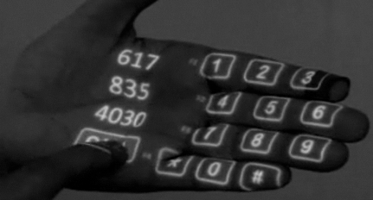

Figure 5.1: Make a call

You can use the Sixth Sense to project a keypad onto your hand, then use that virtual keypad to make a call. Calling a number also will not be a great task with the introduction of Sixth Sense Technology. No mobile device will be required, just type in the number with your palm acting as the virtual keypad. The keys will come up on the fingers. The fingers of the other hand will then be used to key in the number and call.

### Call up a map

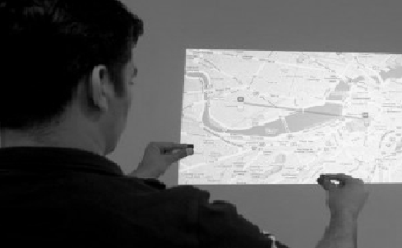

Figure 5.2: Map

The sixth sense also implements map which lets the user display the map on any physical surface and find his destination and he can use his thumbs and index fingers to

5.3 Check the time

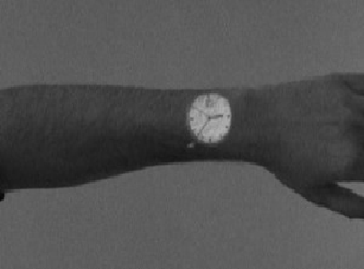

Figure 5.3: Wrist Watch

Sixth Sense all we have to do is draw a circle on our wrist with our index finger to get a virtual watch that gives us the correct time. The computer tracks the red marker cap or piece of tape, recognizes the gesture, and instructs the projector to flash the image of a watch onto his wrist.

### 5.4Create multimedia reading experiences

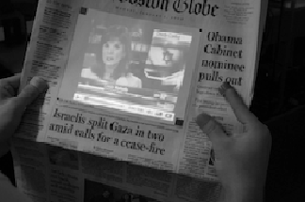

Figure 5.4: Video in Newspaper

The SixthSense system also augments physical objects the user is interacting with by projecting more information about these objects projected on them. For example, a newspaper can show live video news or dynamic information can be provided on a regular

piece of paper. Thus a piece of paper turns into a video display.

### 5.5Drawing application

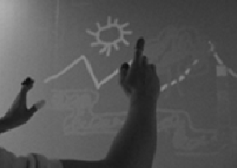

Figure 5.5: Drawing

The drawing application lets the user draw on any surface by tracking the fingertip movements of the user’s index finger.

### Zooming features

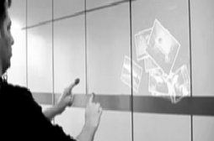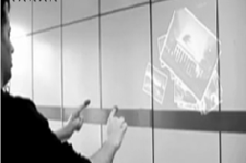

Figure 5.6: Zoom in and Zoom out

The user can zoom in or zoom out using intuitive hand movements.

#### Get product information

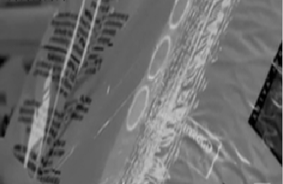

Figure 5.7: Product information

Maes says Sixth Sense uses image recognition or marker technology to recognize products you pick up, then feeds you information on those products. For example, if you're trying to shop "green" and are looking for paper towels with the least amount of bleach in them, the system will scan the product you pick up off the shelf and give you guidance on whether this product is a good choice for you.

### Get book information



Figure 5.8: Book information

Maes says Sixth Sense uses image recognition or marker technology to recognize products you pick up, then feeds you information on books. The system can project Amazon ratings on that book, as well as reviews and other relevant information

#### Take pictures

 

Figure 5.9: Take Pictures

If we fashion our index fingers and thumbs into a square (the typical "framing" gesture), the system will snap a photo. After taking the desired number of photos, we can project them onto a surface, and use gestures to sort through the photos, and organize and resize them.

### Get flight updates



Figure 5.10: Flight updates

The system will recognize your boarding pass and let you know whether your flight is on time and if the gate has changed.

#### Feed information on people



Figure 5.11: Information on people

Sixth Sense also is capable of "a more controversial use”. When you go out and meet someone, projecting relevant information such as what they do, where they work, and also m it could display tags about the person floating on their shirt. It could be handy if it displayed their facebook relationship status so that you knew not to waste your time.

**Chapter 6**

## ADVANTAGES AND ENHANCEMENTS

.

### Advantages

* + - SixthSense is an user friendly interface which integrates digital information into the physical world and its objects, making the entire world your computer.
    - SixthSense does not change human habits but causes computer and other machines to adapt to human needs.
    - It uses hand gestures to interact with digital information.
    - Supports multi-touch and multi-user interaction
    - Data access directly from machine in real time
    - It is an open source and cost effective and we can mind map the idea anywhere
    - It is gesture-controlled wearable computing device that feeds our relevant information and turns any surface into an interactive display.
    - It is portable and easy to carry as we can wear it in our neck.
    - The device could be used by anyone without even a basic knowledge of a keyboard or mouse.
    - There is no need to carry a camera anymore. If we are going for a holiday, then from now on wards it will be easy to capture photos by using mere fingers

### Future Enhancements

* + - To get rid of color markers
    - To incorporate camera and projector inside mobile computing device.
    - Whenever we place pendant- style wearable device on table, it should allow us to use the table as multi touch user interface.
    - Applying this technology in various interest like gaming, education systems etc.
    - To have 3D gesture tracking.
    - To make sixth sense work as fifth sense for disabled person.

## CONCLUSION

The key here is that Sixth Sense recognizes the objects around you, displaying information automatically and letting you access it in any way you want, in the simplest way possible.

Clearly, this has the potential of becoming the ultimate "transparent" user interface for accessing information about everything around us. If they can get rid of the colored finger caps and it ever goes beyond the initial development phase, that is. But as it is now, it may change the way we interact with the real world and truly give everyone complete awareness of the environment around us.

## REFERENCES

1. [www.blendernation.com/sixth-sense-technology/](http://www.blendernation.com/sixth-sense-technology/)
2. <http://boingboing.net/2009/11/12/sixth-sense-technolo.html>
3. <http://gizmodo.com/5167790/sixth-sense-technology-may-change-how-we-look-> at-the-world-forever
4. <http://theviewspaper.net/sixth-sense-technology-will-revolutionize-the-world/>
5. <http://lucasrichter.wordpress.com/2009/03/13/pattie-maes-sixth-sense-> technology-whats-stopping-this/